CNNP Skill-2
G. Neha
2520030409
Stage-1:
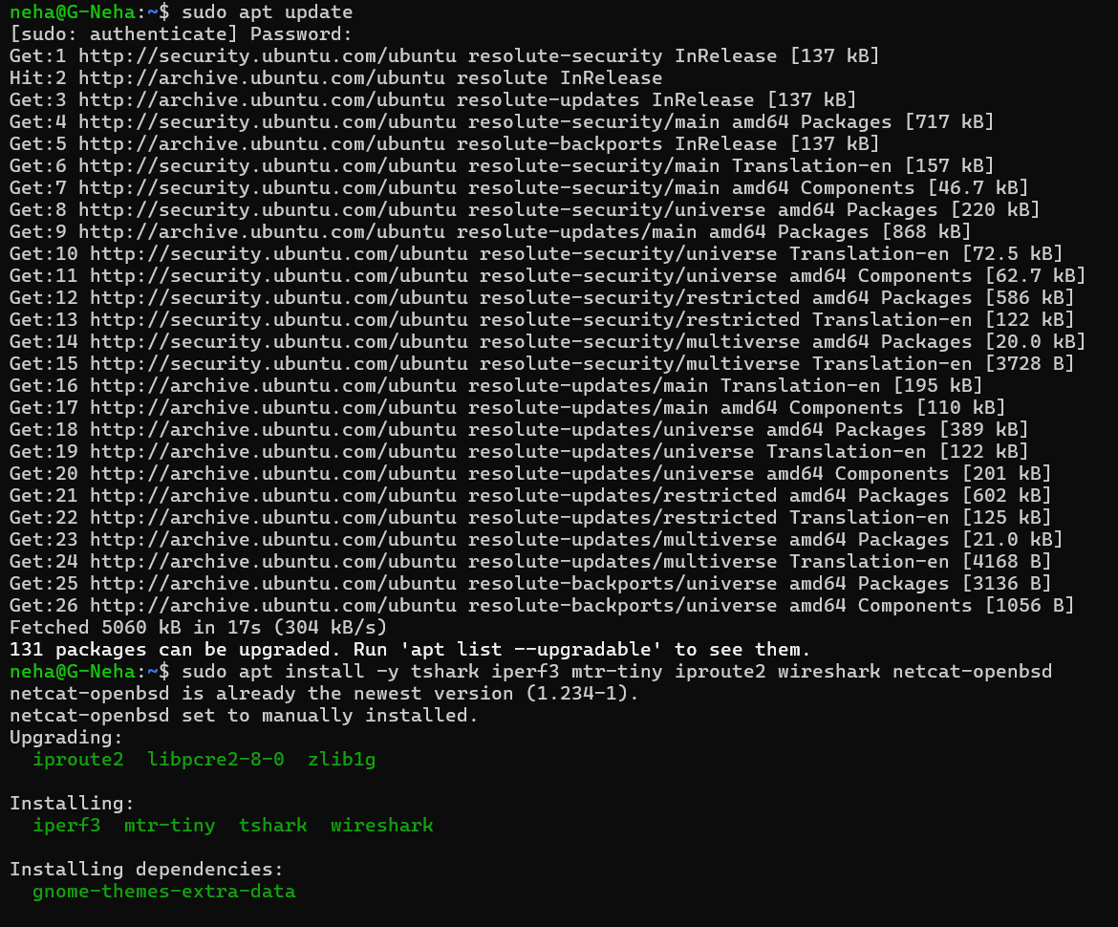

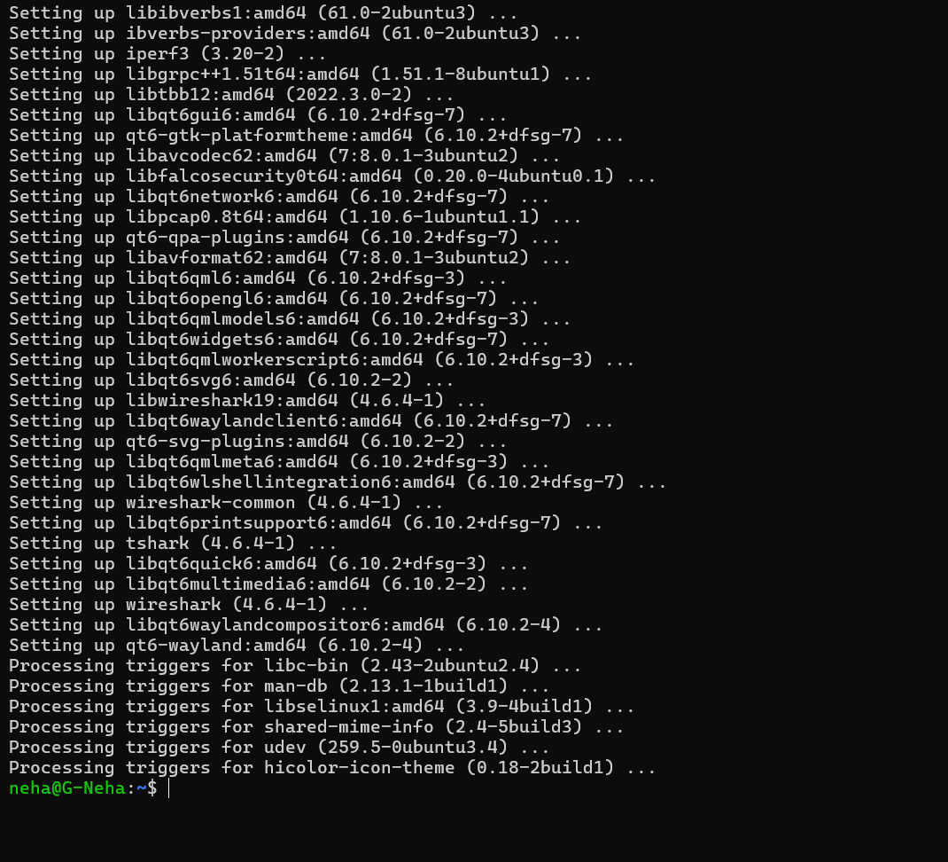

Stage-2 to Stage-6:
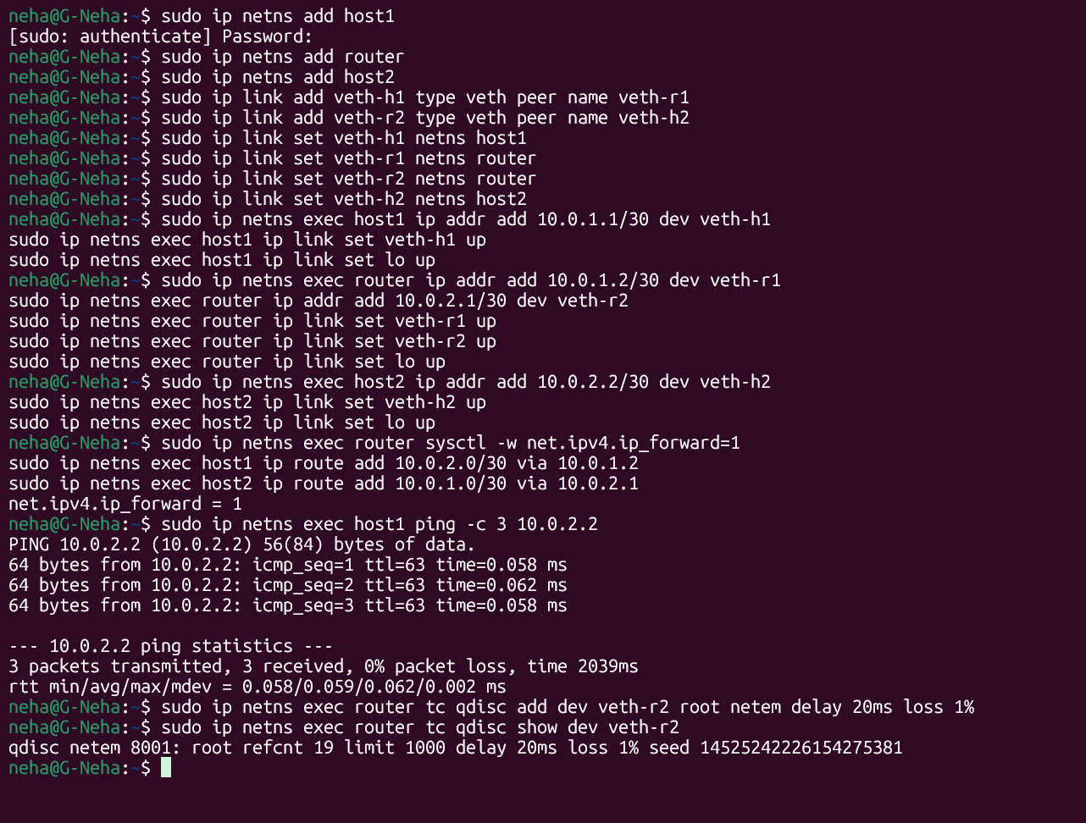
Stage 7 and 8:
Terminal-1:
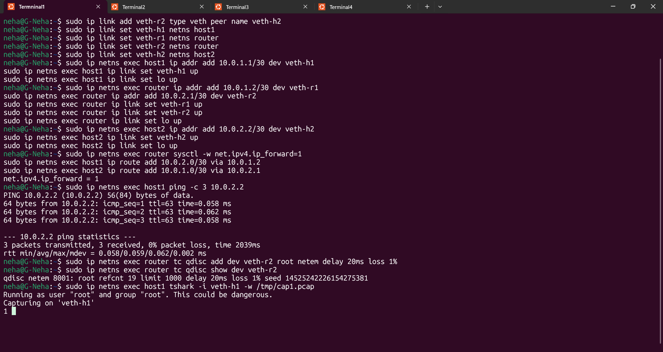
Terminal-2:
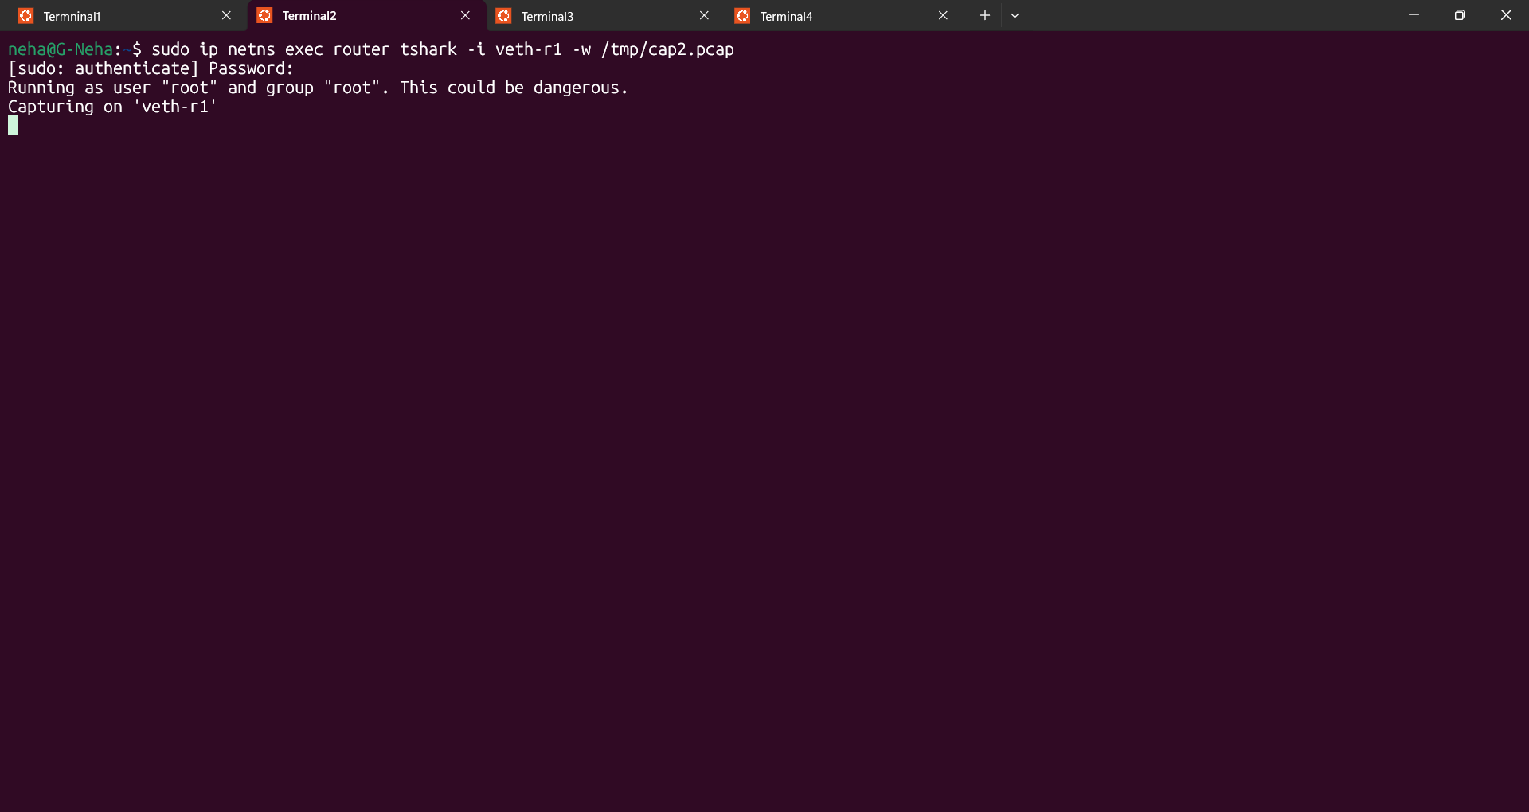
Terminal-3:

Stage-9:
Terminal-4:
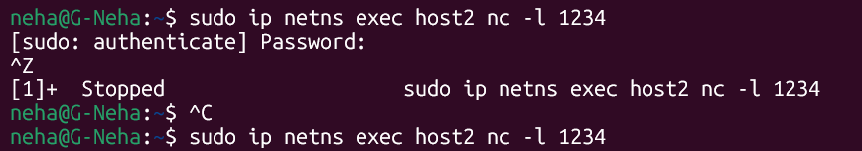
Terminal-5:
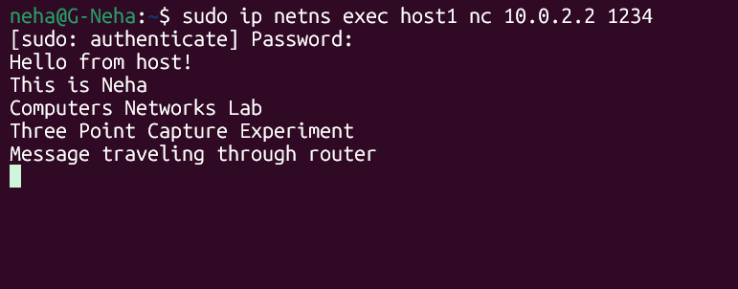
Stage-10:
Terminal-4:
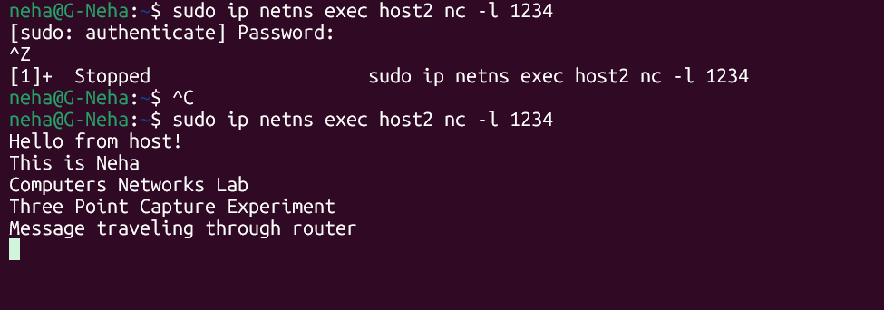
Stage-12:
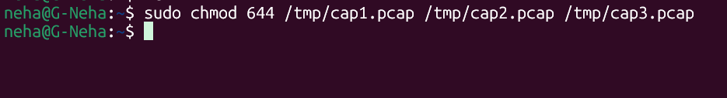

Stage-13:
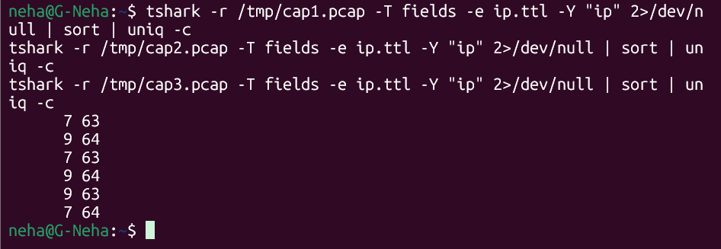
Stage-14:
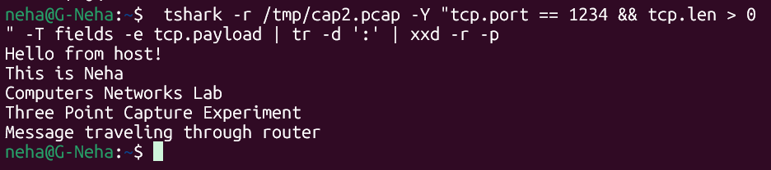
Check delay:
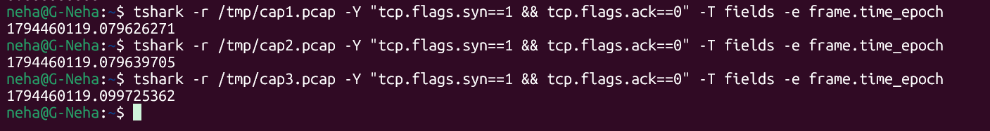
Check re-transmissions:
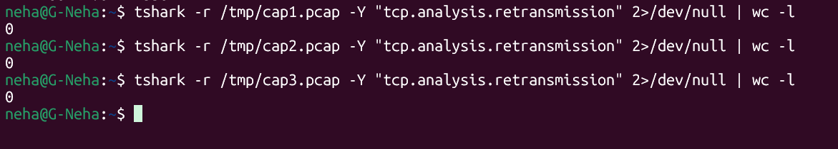
Check RTT:
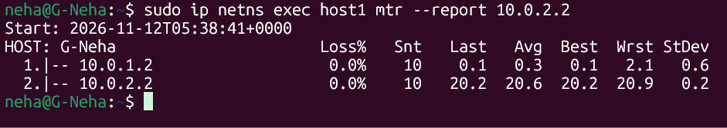
Opening wireshark and merge:
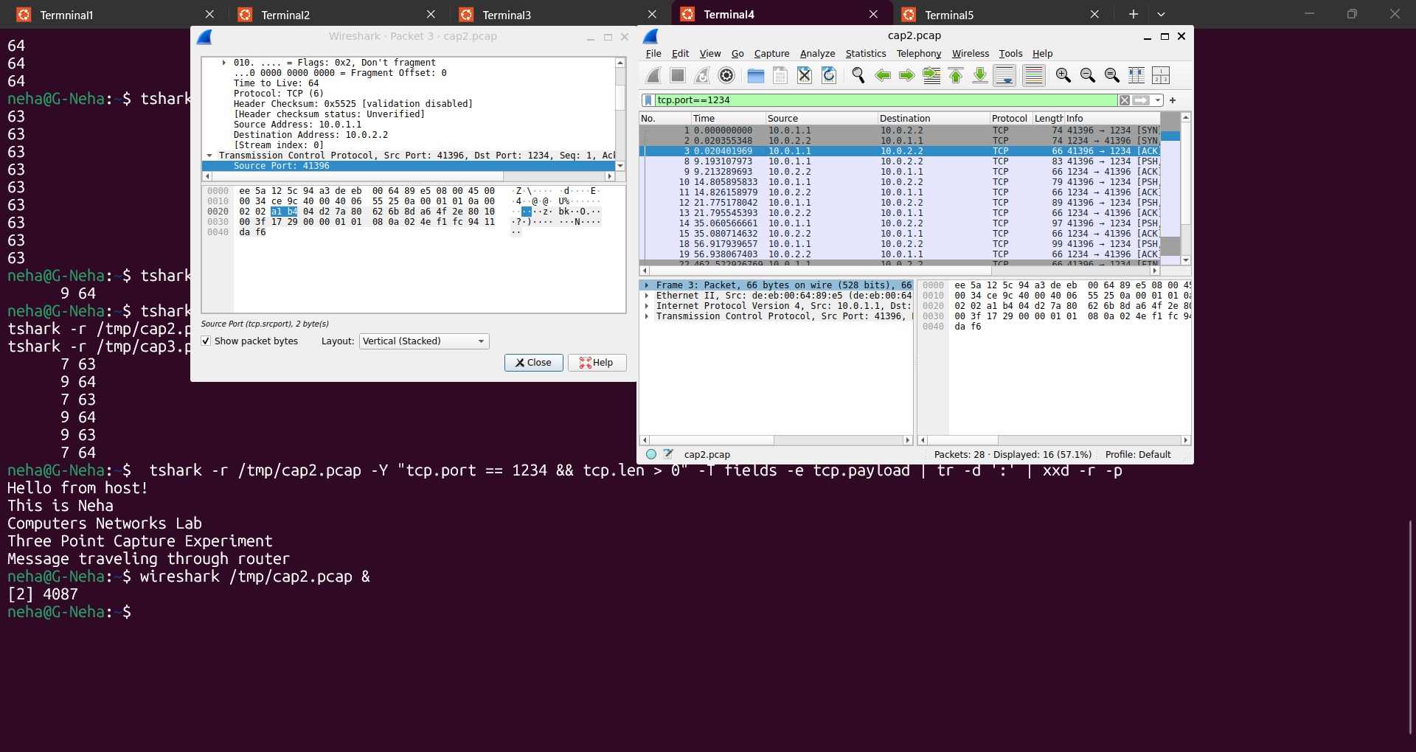
Adding TTL column, Packet loss and analyze:
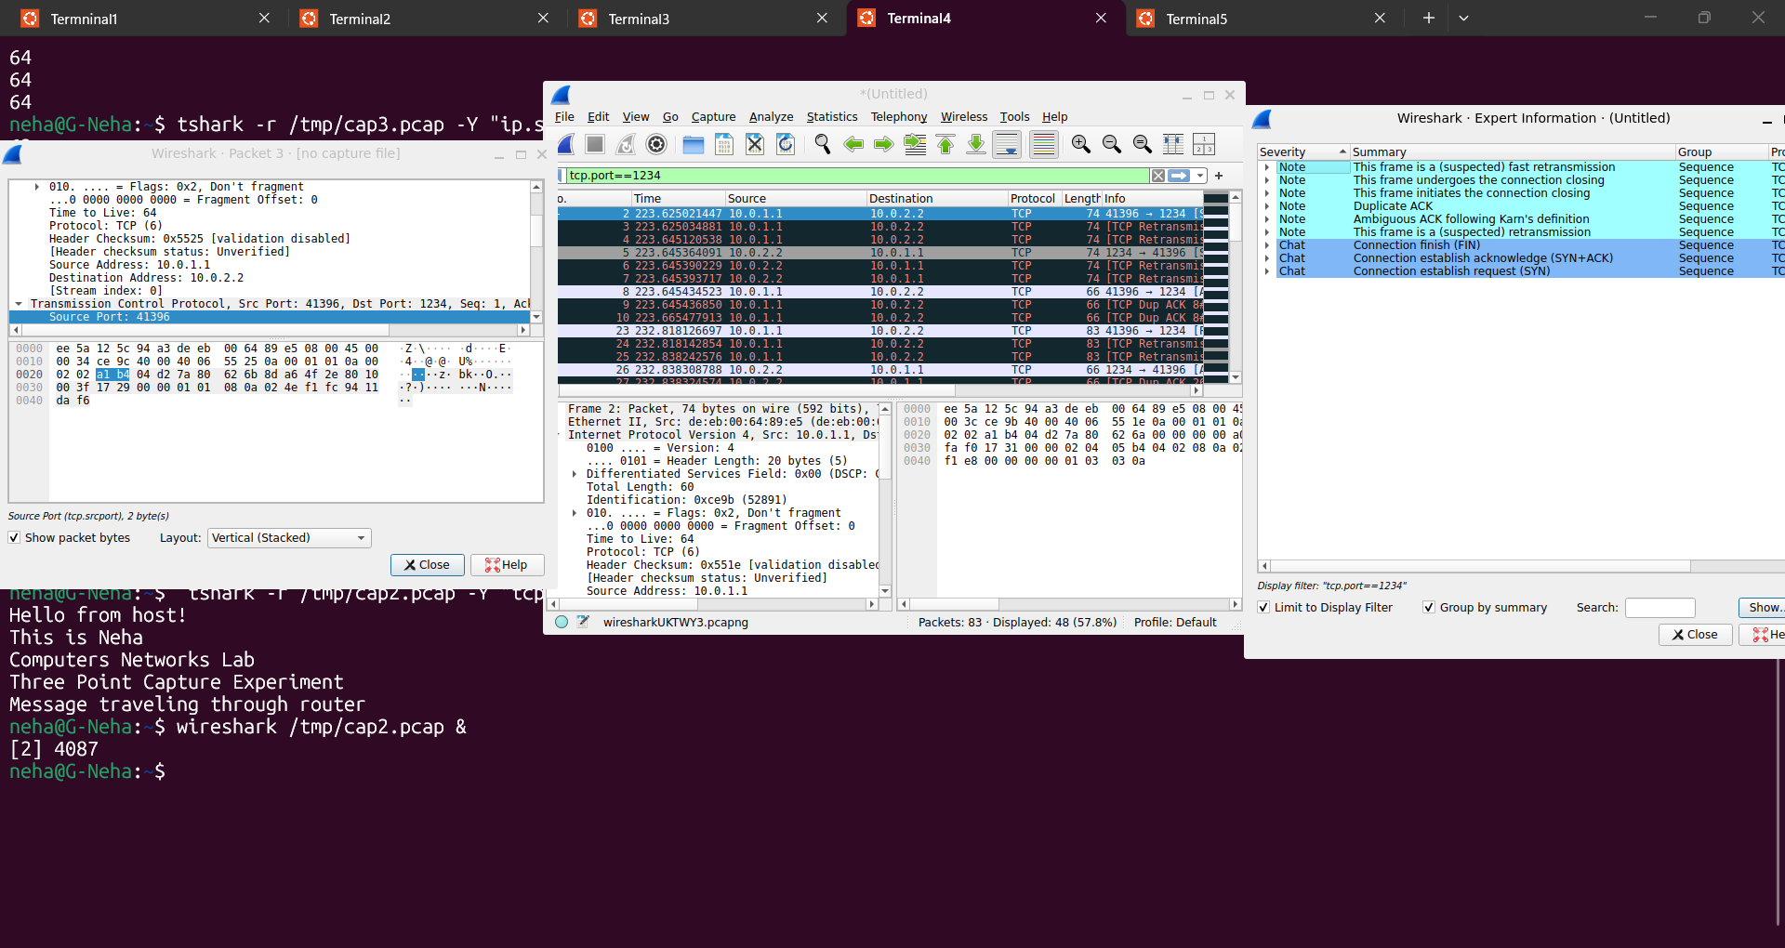
Showing packet loss and verification:


